Binary Information
Binary Name => Beginner Friendly
Language => C/C++
Arch => X86X64
Platform => Unix/Linux
$ file main
main: Mach-O 64-bit x86_64 executable, flags:<NOUNDEFS|DYLDLINK|TWOLEVEL|WEAK_DEFINES|BINDS_TO_WEAK|PIE>
Mach-O binaries basically run on iOS or Mac devices and since I am using Linux as reversing OS platform I cannot perform dynamic analysis. So static analysis will be performed and explained below how to understand the workflow and reverse engineer the binary.

Analysis

Static Analysis
Below is a provided image of the disassembly produced by IDA free 9.2 version in Linux distribution to a rough understanding of the program.

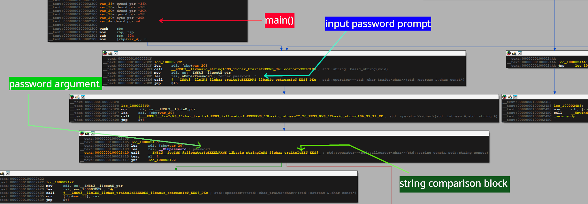

The above image gives us a rough idea about the working of the program.

Program Working
- Takes user string input
- Compares the user input with the predefined password string inside the program
- Enters the => “👍” block if the comparison is true
Of course better analysis could be performed but the binary format is not executable in Linux distributions.
Solving
The crackme challenge can be solved in 2 ways
- Using IDA
- Using strings command in Linux

IDA way
- Open IDA
- Go View tab
- View tab -> Open subviews -> Strings
Analyze the Strings windows carefully and try to find a unique string.

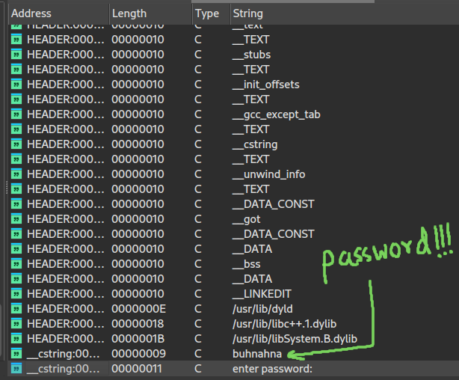

So the password is buhnahna

strings command way
$ strings main | grep -i "buhnahna"
buhnahna

